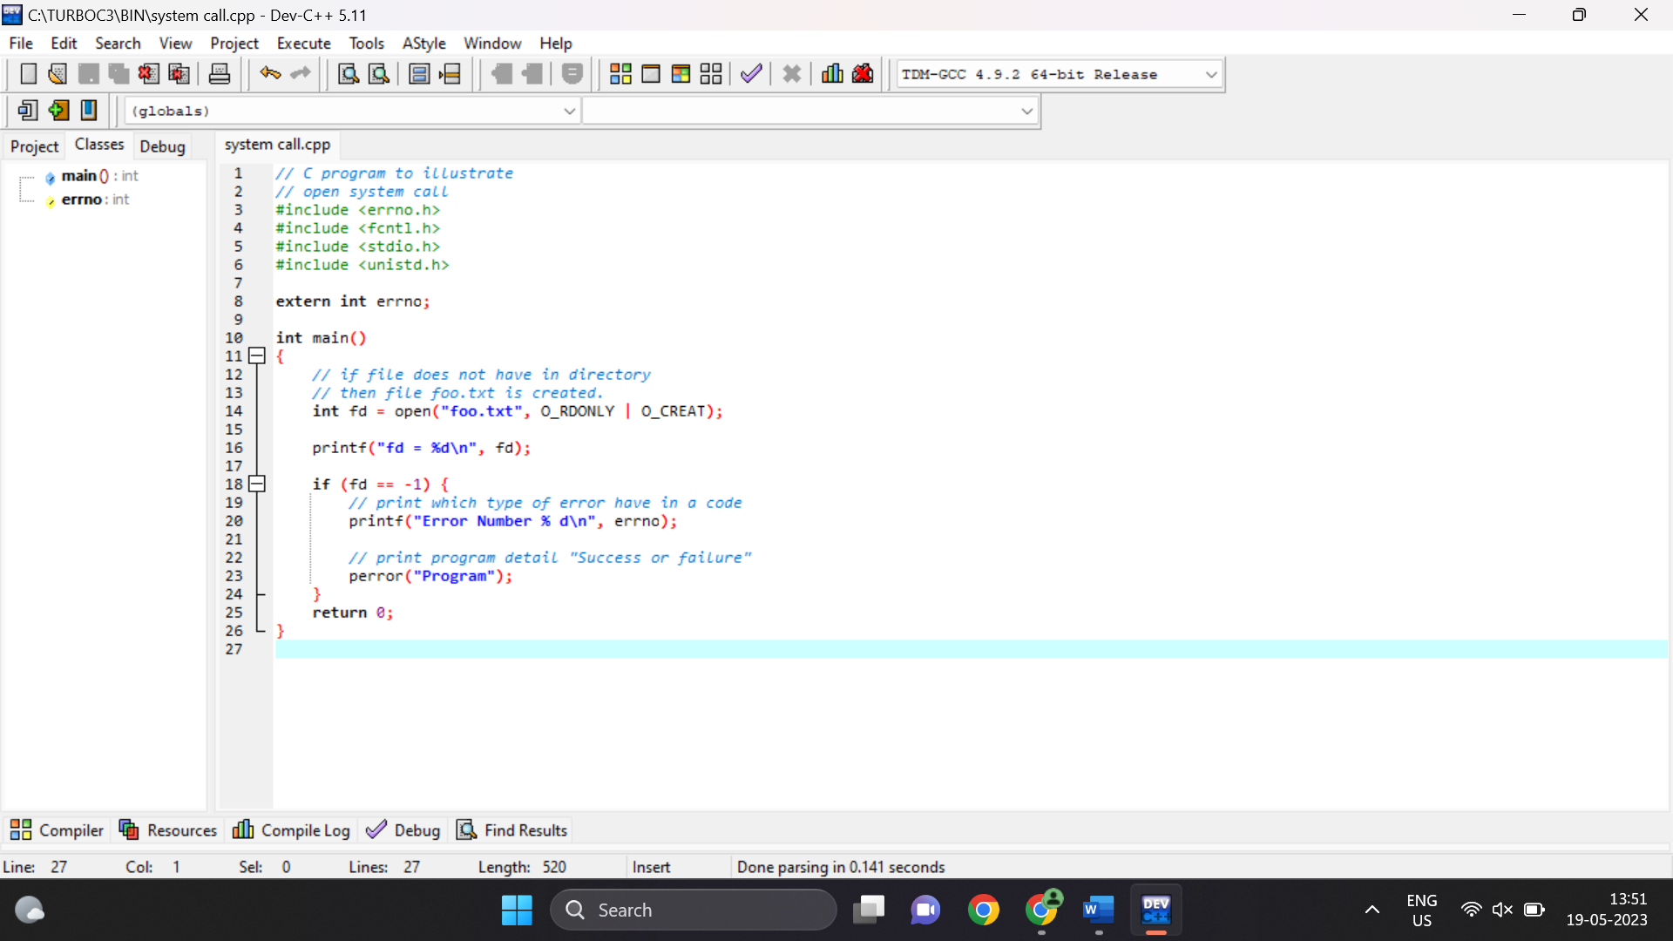

Output:

fd = 3

--------------------------------

Process exited after 0.03243 seconds with return value 0

Press any key to continue . . .